AI-POWERED EMERGENCY EVACUATION ROUTE PLANNING SYSTEM
A PROJECT REPORT

Submitted by
DHARANI K (2116241901025)
DHIVYA M (2116241901027)

in partial fulfillment for the award of the degree
of

BACHELOR OF ENGINEERING
in
COMPUTER SCIENCE AND ENGINEERING
(CYBER SECURITY)


RAJALAKSHMI ENGINEERING COLLEGE
An Autonomous Institute
CHENNAI

NOVEMBER 2026

RAJALAKSHMI ENGINEERING COLLEGE
CHENNAI

BONAFIDE CERTIFICATE

Certified that this Project report titled “AI-POWERED EMERGENCY EVACUATION ROUTE PLANNING SYSTEM” is the bonafide work of “DHARANI K (241901025), DHIVYA M (241901027)” who carried out the project work under my supervision.

SIGNATURE
Dr. S Bhuvana Ph.D.,
SUPERVISOR
ASSISTANT PROFESSOR(SG)
Department of Computer Science and Engineering (Cyber Security)

Rajalakshmi Engineering College Chennai – 602 105
Submitted to Project Viva-Voce Examination held on

SIGNATURE OF THE INTERNAL EXAMINER
ABSTRACT

During emergencies such as floods, fires, earthquakes, and industrial accidents, reaching a safe location quickly is critical. Normal navigation systems are mainly designed for everyday travel and may suggest routes that become unsuitable when roads are blocked or affected by an emergency. This creates a need for an evacuation-oriented route planning system that can consider the changing accessibility of roads and provide an appropriate alternative route.
The proposed AI-Powered Emergency Evacuation Route Planning System is designed to assist users in selecting an efficient evacuation route from their current location to a safe destination. The system represents the available road network as a weighted graph, where locations are treated as nodes and roads connecting them are treated as edges with associated travel costs. The user can select the required locations through the map interface and specify roads that are blocked or unsafe due to the emergency. These unavailable roads are excluded from the route calculation.
To determine the evacuation path, the system applies the A* (A-Star) Search Algorithm, an Artificial Intelligence search technique that combines the actual travel cost with an estimated distance to the destination. This enables the system to search the road network efficiently and identify a suitable available route. When a selected road becomes blocked, the system updates the road network and recalculates the route to provide an alternative path instead of directing the user through the affected area.
The main objective of the proposed system is to provide dynamic and efficient evacuation route planning based on the current availability of roads. By avoiding blocked routes and recalculating alternative paths, the system can reduce unnecessary delays and help users reach designated safe locations through available routes. The proposed approach also demonstrates how AI search techniques can be applied to real-world disaster management problems.
ACKNOWLEDGEMENT
First and foremost, we thank Almighty God for enabling us to complete this project successfully. We express our sincere gratitude to our Chairman, Mr. S. Meganathan, B.E., F.I.E., for his dedicated efforts in providing quality education at this esteemed institution. We are deeply grateful to our beloved Chairperson, Dr. Thangam Meganathan, Ph.D., for her constant motivation and encouragement, which inspired us throughout the completion of this project. We also thank our Vice Chairman, Mr. Abhay Shankar Meganathan, B.E., M.S., for providing the necessary infrastructure and facilities.
We express our sincere gratitude to our College Principal, Dr. S. N. Murugesan, M.E., Ph.D., and Dr. P. Tamilselvi, Ph.D., Professor and Head, Department of Computer Science and Engineering (Cyber Security), for their support and encouragement.
We are especially thankful to our project guide, Dr. Bhuvana S., Ph.D., Assistant Professor(SG), for her valuable guidance, continuous encouragement, and support throughout the project. Finally, we thank our parents and friends for their direct and indirect contributions, encouragement, and support in the successful completion of this project.
DHARANI K (2116241901025)
DHIVYA M (2116241901027)

TABLE OF CONTENTS
CHAPTER NO. |  | TITLE | PAGE NO.
 | ABSTRACT |  |  | iii
 | LIST OF TABLES |  |  | vii
 | LIST OF FIGURES |  |  | viii
1 | INTRODUCTION |  |  | 1
 | - BACKGROUND |  |  | 1
 | 1.2 PROBLEM STATEMENT |  |  |  | 1
 | 1.3 OBJECTIVES |  |  |  | 2
 | 1.4 SCOPE |  |  |  | 2
 | 1.5 SECURITY REQUIREMENTS/  SECURITY CONSIDERATIONS  1.6 SDG ALIGNMENT |  |  |  | 3  3
2 | LITERATURE REVIEW |  |  | 4
 | 2.1 EXISTING SYSTEM WITH  SECURITY APPROACHES |  |  | 4
 | 2.2 RESEARCH GAPS |  |  | 5
 | 2.3 PROPOSED SYSTEM |  |  | 6
 | 2.3.1 OVERVIEW OF THE  PROPOSED SYSTEM |  |  | 6
 | 2.3.2 OBJECTIVES OF THE  PROPOSED SYSTEM |  |  | 6
 | 2.3.3 ADVANTAGES OF  PROPOSED SYSTEM |  |  | 7
3 | SYSTEM DESIGN |  |  | 8
 | 3.1 SYSTEM ARCHITECTURE |  |  | 8
 | 3.2 MODULE DESIGN  3.3 DATA FLOW/UML DIAGRAMS  3.4 THREAT MODEL AND ATTACK SURFACE  3.5 SECURITY CONTROLS |  |  | 9  9  11  12
4 | SYSTEM DESCRIPTION |  |  | 13
 | 4.1 DATA COLLECTION |  |  | 13
 | 4.2 DATA PREPROCESSING |  |  | 13
 | 4.2.1 ALGORITHMS /  METHODOLOGY |  |  | 13
 | 4.2.2 RESULTS AND  DISCUSSION |  |  | 14
5 | CONCLUSION |  |  | 16
 | 5.1 CONCLUSION |  |  | 16
 | 5.2 FUTURE WORK |  |  | 16
 | REFERENCES |  |  | 17
 | APPENDIX |  |  | 18
LIST OF TABLES

TABLE NO. | TITLE | PAGE NO.
1.1 | SDG ALIGNMENT | 3
3.1 | HARDWARE REQUIREMENTS | 9
4.1 | ROUTE PLANNING RESULTS | 15
4.2 | COMPARISON WITH EXISTING APPROACH | 15
LIST OF FIGURES
FIGURE | TITLE | PAGE NO.
2.1 | EXISTING SYSTEM | 4
2.2 | PROPOSED SYSTEM | 6
3.1 | SYSTEM ARCHITECTURE | 8
3.2 | DATA FLOW DIAGRAM | 10
3.3 | USE CASE DIAGRAM | 10
3.4 | CLASS DIAGRAM | 11
4.1 | SAFE ROUTE SCREENSHOT | 14
4.2 | BLOCKED ROAD HIGHLIGHTED ON THE MAP | 15

CHAPTER 1
INTRODUCTION
1.1 BACKGROUND
Emergency situations such as floods and road blockages can make normal road routes unsafe. Natural disasters such as floods, fires, earthquakes and industrial accidents often require people to evacuate quickly, and during such events many roads may become blocked or unsafe, making it difficult to identify a secure evacuation route.
This project, titled “AI-Powered Emergency Evacuation Route Planning System”, uses OpenStreetMap road network data for Chennai [7]. The road network is represented as a graph of interconnected locations in which each road is assigned a travel cost. The A* (A-Star) Search Algorithm [13] is used to find safe evacuation routes, hazardous roads are avoided, and alternate routes are identified. The safe route is displayed on an interactive web map.
The project domain comprises Artificial Intelligence, Graph-Based Route Optimization and Geospatial Mapping. The application areas are Emergency Evacuation Planning, Disaster Management, Safe Route Navigation and Smart City Transportation.
The system helps to identify safer evacuation routes during emergencies and avoids blocked and hazardous roads while planning routes. It uses the A* Search Algorithm for efficient route finding, provides real-time visual route information through an interactive map, and supports faster and safer decision-making during emergency situations. The project was selected to develop a practical solution for safe evacuation route planning, to explore the use of AI and graph-based search for route optimization, and to apply real-world road network and hazard data to a real-world problem.
1.2 PROBLEM STATEMENT
Conventional navigation may not consider emergency-specific road hazards, and blocked roads can lead to unsafe or inefficient routes. There is therefore a need for a system that combines hazard information with route planning.
The problem needs to be addressed because unsafe routes during emergencies can delay evacuation, whereas avoiding hazardous roads can improve route safety and efficiency. Quick route selection is important for emergency response and evacuation. A system is needed to identify hazardous roads and avoid them. The proposed system uses the A* Search Algorithm to find alternate routes, and an interactive map provides a clear visual representation of the safe route.
1.3 OBJECTIVES
The objectives of the project are:
- To develop an AI-based emergency evacuation route planning system for Chennai that helps users identify suitable evacuation routes using the Chennai road network.
- To implement the A* Search Algorithm for finding an efficient and safe route between the selected source and destination.
- To identify and avoid hazardous roads, preventing blocked or flooded roads from being used in the safe route.
- To provide an alternate safe route when the original path contains a blocked or hazardous road.
- To recalculate the route whenever road conditions change.
- To reduce evacuation time by selecting an optimal path.
- To visualize evacuation routes and hazards on an interactive web map.
- To improve public safety during natural disasters.
1.4 SCOPE
The scope of the project is the planning of emergency evacuation routes on the Chennai road network obtained from OpenStreetMap. Users select a start location and a destination, either from the six predefined Chennai locations or by clicking a location marker on the map. Hazard information, namely blocked and flooded roads, is read from a CSV file (hazards.csv), and hazardous roads are removed from the routing network. The A* Search Algorithm then calculates a safe route, and the route and the hazards are displayed on an interactive web map.
The system is applicable to Emergency Evacuation Planning, Disaster Management, Safe Route Navigation and Smart City Transportation. Comparison with existing methods, performance evaluation and the preparation of the final system documentation are planned as future work (Chapter 5).

1.5.SECURITY REQUIREMENTS/ SECURITY CONSIDERATION
- Data Integrity: Ensure that the road network and hazard data stored in hazards.csv are accurate and not modified by unauthorized users.
- Input Validation: Validate source and destination selections before calculating evacuation routes.
- Hazard Data Validation: Verify hazard entries to prevent invalid road-node pairs from affecting route planning.
- Web Application Security: Validate API requests and handle errors safely in the Flask web server.
- Availability: Ensure the application can access the stored road network and display routes when required.
1.6 SDG ALIGNMENT
The project contributes to the following Sustainable Development Goals (SDGs):
S. No. | SDG No. & Goal | Relevant SDG Target | Project Contribution / Alignment
1 | SDG 11 – Sustainable Cities and Communities | Target 11.5 – Reduce the number of deaths and the number of people affected by disasters, including water-related disasters. | Provides safe evacuation routes in Chennai that avoid blocked and flooded roads, supporting safer and faster evacuation during emergencies and smart city transportation.
2 | SDG 13 – Climate Action | Target 13.1 – Strengthen resilience and adaptive capacity to climate-related hazards and natural disasters. | Supports disaster management by identifying hazardous roads, regenerating an alternate safe route when road conditions change, and visualizing the route on an interactive map.

Table 1.1 SDG ALIGNMENT
CHAPTER 2
LITERATURE REVIEW
2.1 EXISTING SYSTEM WITH SECURITY APPROACHES
The existing approach uses normal map-based route planning, in which a user selects a destination and the system provides the shortest route to it. The technologies and algorithms used are GPS, digital maps and Dijkstra or other shortest-path algorithms. Such systems are easy to use, perform fast route calculation and are easily available.
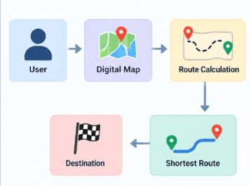
Figure 2.1 Existing System
Gaitanis et al. [1] (2023) proposed route planning for emergency evacuation using graph traversal algorithms, in which a floor-plan graph is generated and Dijkstra’s Algorithm is used to find the shortest evacuation path. The work mainly focuses on the shortest path and is less suitable for changing emergency conditions. Dijkstra’s Algorithm searches many nodes before reaching the destination, does not use heuristic information, requires higher execution time for large road networks, and its performance decreases as the graph size increases.
Huang et al. [2] (2024) presented a real-time automatic fire emergency evacuation route selection model based on Multi-Criteria Decision Making, which selects suitable evacuation routes by considering multiple emergency factors. The limitation is that the decision-making is more complex and may require more input information.
“Help Me Evacuate! A Smart Adaptable Evacuation System” [3] (2023) uses intelligent route planning to provide adaptable routes that support safe emergency evacuation, but it may have limited dynamic route recalculation for newly blocked roads. Other related studies include a route guidance map for emergency evacuation [4], integrated evacuation route planning based on real-time data acquisition [5], and sensing, calculating and disseminating evacuating routes during an indoor fire [6].
The limitations of the existing map-based systems are that they cannot handle sudden road blocks effectively, do not dynamically avoid flooded or hazardous roads, and may provide a route that becomes unsafe during emergencies. Security approaches used in the existing systems:
- Secure Data Handling: Existing navigation systems may use data validation to maintain the reliability of road and location information.
- Access Control: Some systems restrict access to sensitive information and administrative functions.
- Secure Communication: Systems may use HTTPS to protect data exchanged between users and servers.
- Data Integrity: Validation mechanisms help identify incorrect or inconsistent road and hazard information.
- Privacy Protection: Location data should be handled carefully to protect user privacy.
Note: The specific security approaches used by existing systems were not specified in the project materials. The points above are general examples and should not be presented as verified features of a particular existing system.
2.2 RESEARCH GAPS
The following research gaps were identified from the literature survey and the existing system:
• Conventional navigation does not consider emergency-specific road hazards and cannot handle sudden road blocks effectively.
• Shortest-path approaches mainly focus on the shortest path and are less suitable for changing emergency conditions.
• Dijkstra-based graph traversal does not use heuristic information, searches many nodes, and takes more time for large road networks and for route recalculation.
• Multi-criteria decision-making approaches are more complex and may require more input information.
• Intelligent route planning approaches may have limited dynamic route recalculation for newly blocked roads.
2.3 PROPOSED SYSTEM
2.3.1 OVERVIEW OF THE PROPOSED SYSTEM
The proposed system uses the A* Search Algorithm to calculate the safest evacuation route on the Chennai road network obtained from OpenStreetMap. Blocked and flooded roads are avoided. The key features of the system are hazard detection, a safe alternate route, an interactive map and emergency route planning. The working of the system is as follows:
1. The user enters the source location.
2. The user selects the destination.
3. Blocked roads are marked.
4. The road network is converted into a graph.
5. The A* Search Algorithm calculates the safest route.
6. An alternative path is generated if a road becomes blocked.
7. The final safe route is displayed.
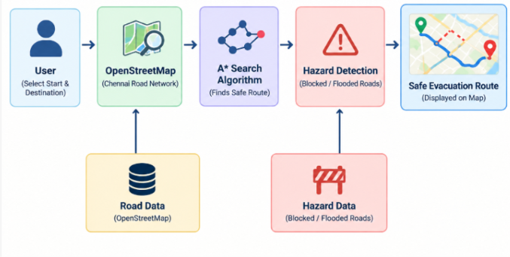
Figure 2.2 Proposed System
2.3.2 OBJECTIVES OF THE PROPOSED SYSTEM
The proposed system aims to avoid unsafe roads, to find an alternate route automatically when the normal route is affected, and to provide the route visually on the map. The expected outcomes are a safe evacuation route, faster route planning and reduced risk during emergencies.

2.3.3 ADVANTAGES OF PROPOSED SYSTEM
• Real-time hazard-aware routing – blocked and flooded roads are removed from the routing network before the A* search.
• Dynamic rerouting – when hazards change, a safe alternate route is generated automatically.
• OSM-based real road network – actual Chennai road network data is used rather than a fixed sample graph.
• Visual hazard representation – blocked roads, flooded roads and the safe A* route are shown directly on the map.
• Integrated emergency decision system – location selection, hazard detection, A* routing and the visual safe route are combined in one pipeline.
CHAPTER 3
SYSTEM DESIGN
3.1 SYSTEM ARCHITECTURE
The system takes the selected locations and hazard information as input. The Chennai road network is obtained from OpenStreetMap and the locations are mapped to road nodes. The A* Search Algorithm then calculates a safe route while avoiding hazardous roads. Finally, the selected safe evacuation route is displayed on an interactive map. The architecture is shown in Figure 3.1.
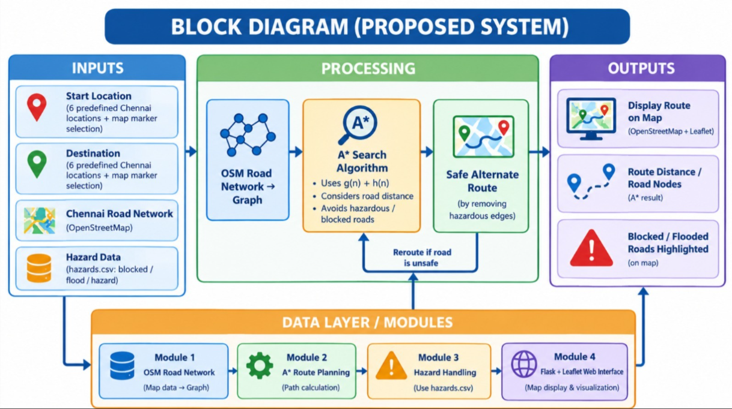
Figure 3.1 System Architecture
The proposed system takes the start location and destination as inputs from six predefined Chennai locations or through map marker selection. It uses the Chennai road network obtained from OpenStreetMap and hazard information stored in hazards.csv, which contains blocked and flooded roads. The road network is converted into a graph, and the A* Search Algorithm calculates the safest available route using the cost function \(f(n)=g(n)+h(n)\), considering road distance and estimated distance to the destination. Hazardous and blocked roads are avoided by removing unsafe edges from the graph, and an alternative route is calculated when necessary. Finally, the system displays the recommended evacuation route using OpenStreetMap and Leaflet, along with the route distance, road nodes, and highlighted blocked and flooded roads. The hardware requirements for implementing the system are presented in Table 3.1.
Component | Specification
Processor | Intel Core i3 or above
RAM | 4 GB minimum
Storage | 20 GB free space
Input devices | Keyboard and Mouse
System | Laptop/Desktop with Internet Connection
.
Table 3.1 Hardware Requirements

The software requirements are: Windows 10/11 operating system; Python programming language; Visual Studio Code / PyCharm as the IDE (Visual Studio Code and PowerShell as the tools used); the libraries Flask, OSMnx, NetworkX, Matplotlib and Leaflet; and Git as optional version control. The map data source is OpenStreetMap and hazard data is stored in CSV files.
3.2 MODULE DESIGN
The system is organised into five modules:
- Module 1 – OSM Road Network & Location Handling: obtains the Chennai road network from OpenStreetMap and converts the map data into a graph; the selected locations are mapped to road nodes.
- Module 2 – A* Route Planning: calculates the route between the selected source and destination using the A* Search Algorithm.
- Module 3 – Hazard Detection & Rerouting: uses the hazard data (hazards.csv) to remove blocked and flooded roads from the routing network and finds an alternate route when the normal route is affected.
- Module 4 – Map Visualization & Web Server: a Flask and Leaflet web interface that displays the map, the safe route and the hazardous roads.
- Module 5 – Emergency Route Output & Evaluation: produces the safe evacuation route and evaluates it by route distance, number of nodes and safe route availability.
3.3 DATA FLOW/UML DIAGRAMS
The data flow of the system follows the stages Input, Preprocessing, Proposed Method/Model, Evaluation and Output, as shown in Figure 3.2. The data used and produced at each step is as follows:

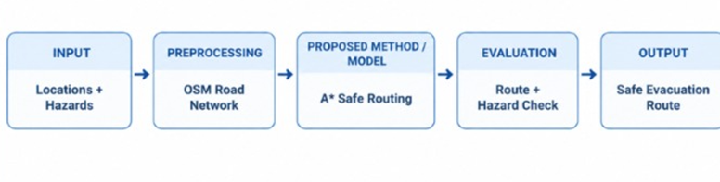
Figure 3.2 Data Flow Diagram
1. Input: the Chennai road network, the selected locations and the hazard data.
2. Road network preparation and location-to-node mapping (OSM road network).
3. Road nodes, road distances and hazard information.
4. A* Search Algorithm with hazard avoidance (A* safe routing).
5. Evaluation: route distance, number of nodes and safe route availability (route and hazard check).
6. Output: the safe evacuation route displayed on an interactive web map.

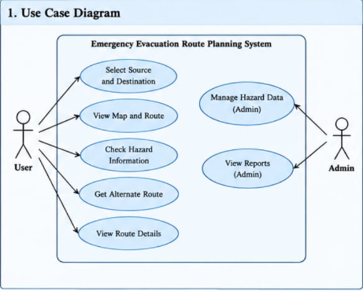

Fig 3.3 Use Case Diagram

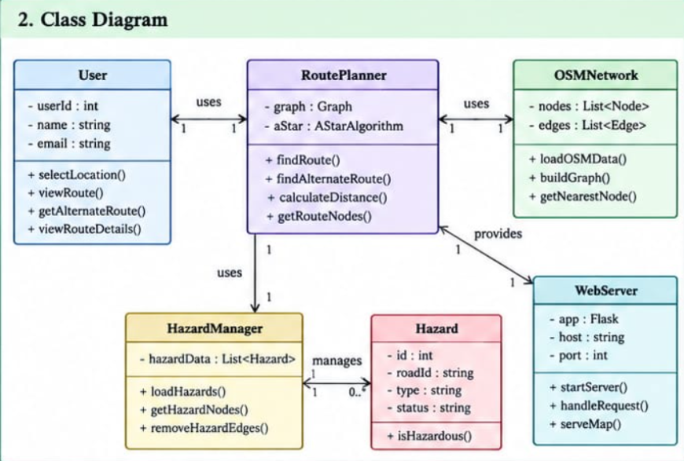Fig 3.4 Class Diagram

3.4 THREAT MODEL AND ATTACK SURFACE
Threat Model
- False Hazard Data: Incorrect blocked-road or flood information may lead to unsuitable evacuation routes.
- Road Network Errors: Incomplete or outdated OpenStreetMap data may affect route accuracy.
- Unauthorized Data Modification: An attacker could modify hazards.csv and influence route planning.
- Route Manipulation: Altered source, destination, or routing requests could produce unexpected results.

Attack Surface
- Web Interface: Source and destination selection, route requests.
- Flask Server: API endpoints such as /api/route, /api/hazards, and /api/locations.
- Hazard Database: hazards.csv, containing road-node pairs and hazard status.
- External Map Data: OpenStreetMap road-network data.
Security Measures / Mitigation
- Validate source, destination, and hazard inputs.
- Restrict unauthorized modification of hazard data.
- Handle invalid requests and routing errors safely.
- Verify hazard information before using it for evacuation decisions.
3.5 SECURITY CONTROLS
- Input Validation: Validate source and destination selections before route calculation.
- Hazard Data Protection: Restrict unauthorized access and modifications to hazards.csv.
- API Validation: Validate requests received by the Flask server.
- Error Handling: Handle invalid inputs and route-not-found situations safely.
- Data Integrity: Verify hazard node IDs and statuses before using them for rerouting.
- Safe Route Verification: Check that the calculated route avoids the road edges marked
CHAPTER 4
SYSTEM DESCRIPTION
4.1 DATA COLLECTION
The data used by the system is collected from the following sources:
• Road network data: the Chennai road network is obtained from OpenStreetMap [7] using the OSMnx library [8].
• Locations: six predefined Chennai locations (for example, L6 – Guindy and L3 – Marina Beach) can be selected as the start location and the destination, or a location marker can be clicked on the map.
• Hazard data: blocked and flooded roads are maintained in a CSV file (hazards.csv). CSV files are used as the data store of the system.
4.2 DATA PREPROCESSING
Before route calculation, the road network is prepared and the selected locations are mapped to road nodes. The road network is converted into a graph, using NetworkX [9], consisting of road nodes and roads with their road distances as travel costs. The hazard information is then read from the hazard data, and the hazardous (blocked or flooded) roads are removed from the routing network so that they cannot be used in the safe route. The resulting graph is given to the A* Search Algorithm.
4.2.1 ALGORITHMS / METHODOLOGY
The AI technique used is the A* (A-Star) Search Algorithm [13], which finds an efficient route between the source and the destination by using the evaluation function f(n) = g(n) + h(n), where g(n) is the cost of the path from the start node to node n (road distance) and h(n) is the heuristic estimate of the cost from node n to the destination. Because the heuristic guides the search, A* avoids the exhaustive exploration of many nodes that is characteristic of Dijkstra’s Algorithm in the existing system.
The methodology followed is:
1. The Chennai road network, the selected locations and the hazard data are taken as input.
2. The road network is prepared and the locations are mapped to road nodes.
3. Road nodes, road distances and hazard information are used to build the routing graph.
4. The A* Search Algorithm with hazard avoidance calculates the safe route; if a road becomes blocked, an alternative path is generated.
5. The route distance, the number of nodes and the safe route availability are evaluated.
6. The safe evacuation route is displayed on an interactive web map.
The technologies used are Python [10] as the programming language; Flask [11], OSMnx [8], NetworkX [9] and Leaflet [12] as frameworks and libraries; CSV files as the database; OpenStreetMap as the map data; and VS Code and PowerShell as the tools.

4.2.2 RESULTS AND DISCUSSION
The web interface provides drop-down lists to select the Start Location and the Destination, the buttons “Find Safe Route” and “Clear Route”, and the option to click a location marker on the map to select the start and destination. Figure 4.1 shows the result for the start location L6 – Guindy and the destination L3 – Marina Beach, where the system displays the message “Safe evacuation route found successfully!” and draws the route on the OpenStreetMap-based map.
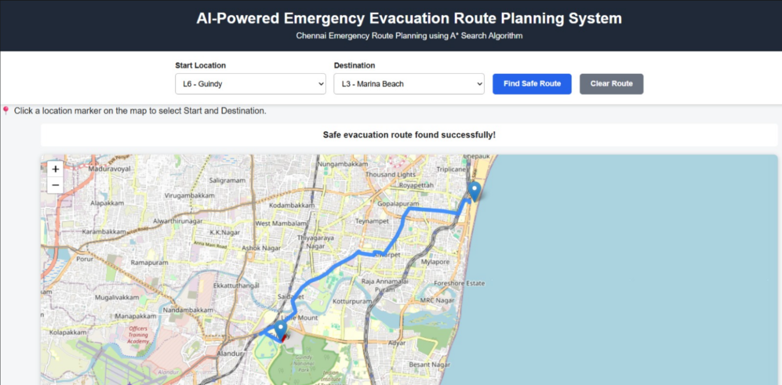
Figure 4.1 Safe Route Screenshot
Figure 4.2 shows a zoomed view of the map in which a blocked road is highlighted on the map along with the displayed route. In the system, blocked roads are shown in red, flooded roads in orange and the safe A* route in blue. The normal route and the hazard-affected route were tested successfully in the preliminary work.
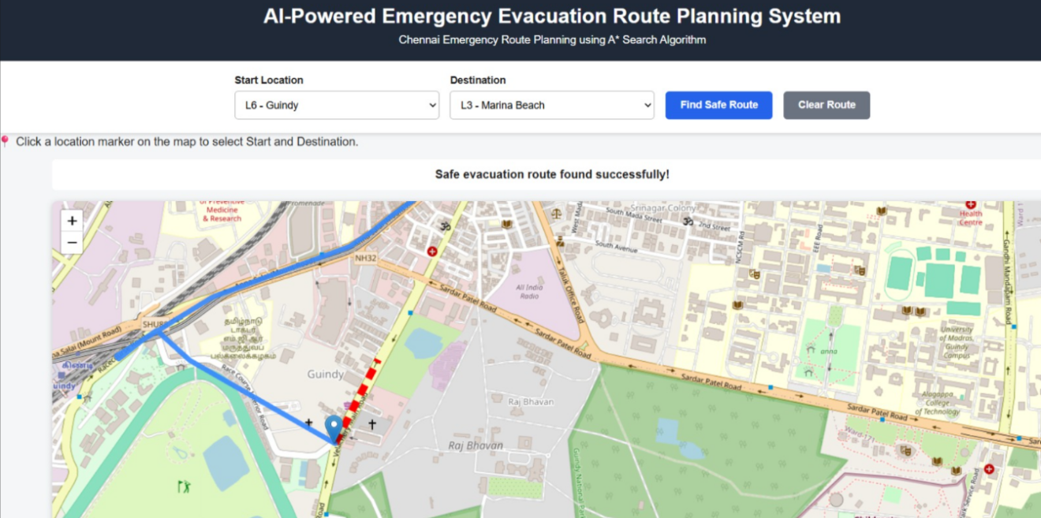
Figure 4.2 Blocked Road Highlighted on the Map
Metric | Normal A* Route | After Hazard
Start Location | Chennai Central | Chennai Central
Destination | Government General Hospital | Government General Hospital
Number of Nodes | 23 | 25
Route Distance | 2,320.95 m | 2,423.04 m
Hazard Avoidance | No hazard removed | Blocked road avoided

Table 4.1 Route Planning Results
Existing Approach | Proposed System
Normal route selection | Hazard-aware route planning
May not account for manually recorded hazards | Uses hazard information from hazards.csv
Alternate routing depends on the navigation system | Re-runs A* after hazardous edges are removed

Table 4.2 Comparison with Existing Approach

CHAPTER 5
CONCLUSION
5.1 CONCLUSION
The proposed system successfully combines OpenStreetMap road data and the A* Search Algorithm to plan emergency evacuation routes. It maps the selected locations to the road network and calculates a suitable route between the source and the destination.
The system also considers hazard information such as blocked roads and removes hazardous roads from the routing network. This allows the system to generate an alternate safe route when the normal route is affected.
Finally, the generated route is displayed through an interactive web map. Thus, the system provides a simple approach for visualizing safe evacuation routes during emergency situations.
As future work, the remaining modules are to be completed, the system is to be compared with the existing routing approach, the route distance, nodes and safe rerouting performance are to be evaluated, and the final system screenshots, results and documentation are to be prepared.

5.2 FUTURE WORK
The future enhancement of the proposed system focuses on improving the accuracy, efficiency, and reliability of emergency evacuation route planning. Real-time hazard integration can be implemented to collect updated information about floods, road blockages, and traffic conditions. The system can be enhanced to handle multiple hazardous road segments simultaneously and expanded to cover more locations and road networks across Chennai. Travel-time optimization can be introduced by considering traffic conditions, road accessibility, and hazard severity along with road distance. A mobile application can also be developed to provide easy access to evacuation routes during emergencies. Finally, the system's performance can be evaluated by measuring route distance, computation time, and rerouting efficiency under different emergency scenarios. These enhancements will help provide safer and more efficient evacuation routes during emergency situations.
REFERENCES
[1] A. Gaitanis, A. Lentzas, G. Tsoumakas and D. Vrakas, “Route Planning for Emergency Evacuation Using Graph Traversal Algorithms,” Smart Cities, vol. 6, no. 4, pp. 1814–1831, 2023. https://doi.org/10.3390/smartcities6040084
[2] P. Huang, X. Lin, C. Liu, et al., “A real-time automatic fire emergency evacuation route selection model,” 2024.
[3] Various Authors, “Help Me Evacuate! A Smart Adaptable Evacuation System,” 2023.
[4] Lakshay, A. Agarwal and N. B. Bolia, “Route Guidance Map for Emergency Evacuation,” Journal of Risk Analysis and Crisis Response, vol. 6, no. 3, pp. 135–144, 2016. https://link.springer.com/article/10.2991/jrarc.2016.6.3.3
[5] Z. Han, et al., “Integrated Evacuation Route Planning Based on Real-Time Data Acquisition,” 2013.
[6] J. Liu, R. Rojas-Cessa and Z. Dong, “Sensing, Calculating and Disseminating Evacuating Routes During an Indoor Fire,” 2016.
[7] OpenStreetMap Foundation, “OpenStreetMap,” 2004. https://www.openstreetmap.org/
[8] G. Boeing, “OSMnx: New Methods for Acquiring, Constructing, Analyzing, and Visualizing Complex Street Networks,” 2017. https://osmnx.readthedocs.io/
[9] NetworkX Developers, “NetworkX Documentation,” 2005. https://networkx.org/
[10] Python Software Foundation, “Python Documentation,” 1991. https://docs.python.org/3/
[11] Pallets Projects, “Flask Documentation,” 2010. https://flask.palletsprojects.com/
[12] V. Agafonkin, “Leaflet – JavaScript Library for Interactive Maps,” 2011. https://leafletjs.com/
[13] P. E. Hart, N. J. Nilsson and B. Raphael, “A Formal Basis for the Heuristic Determination of Minimum Cost Paths,” IEEE Transactions on Systems Science and Cybernetics, 1968.

.
APPENDIX

A. Source Code Listings
- modules/osm_network.py – Chennai road network download and storage.
- modules/location_handler.py – Selected locations mapping to OSM nodes.
- module_2/astar.py – A* route planning algorithm.
- module_3/hazard_rerouting.py – Hazard-aware alternate route generation.
- module_4/map_server.py – Flask web server and API endpoints.
- module_4/web/index.html – Web interface.
- module_4/web/map.js – Interactive map, route and hazard visualization.

Project Structure
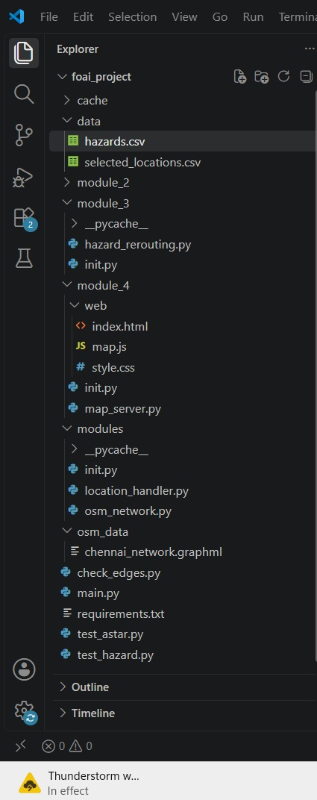
Fig B.1 Project Structure

Screenshots

C.1 Selected Locations.
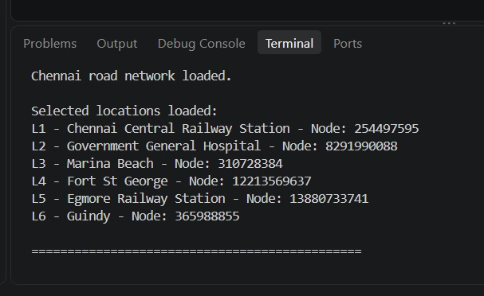
Fig C.1 Selected Locations
C.2 Locations and their mapped node IDs.
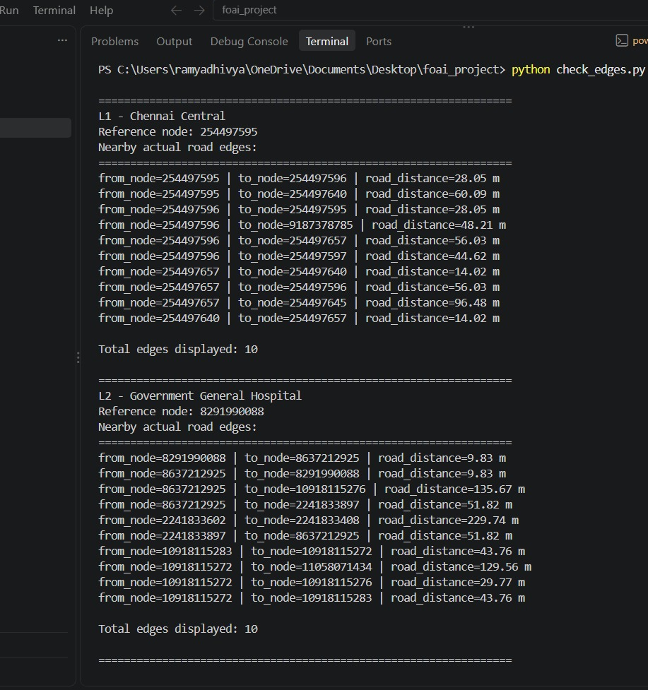
Fig C.2 Mapped nodes of L1 and L2
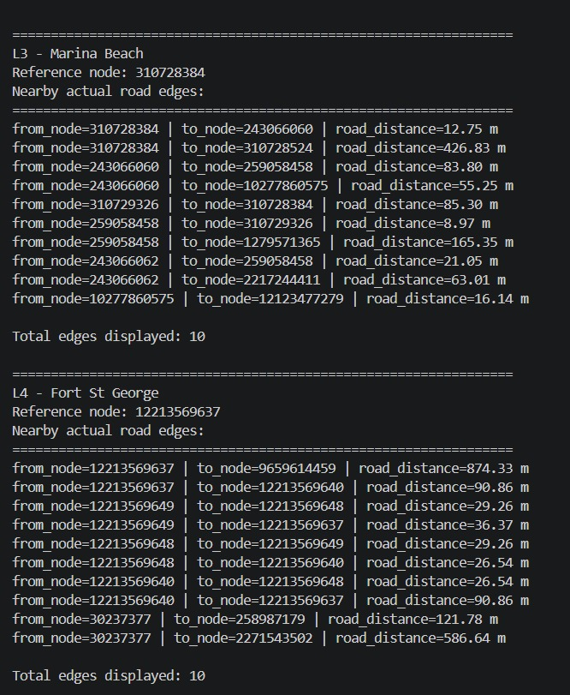
Fig C.3 Mapped nodes of L3 and L4
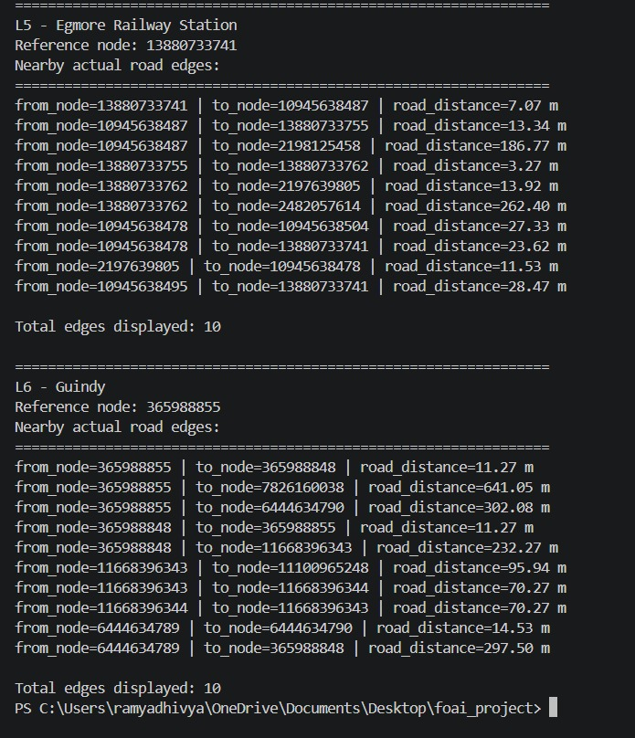
Fig C.4 Mapped nodes of L5 and L6

- Screenshot for Output
D.1 Blocked road highlighed in red.
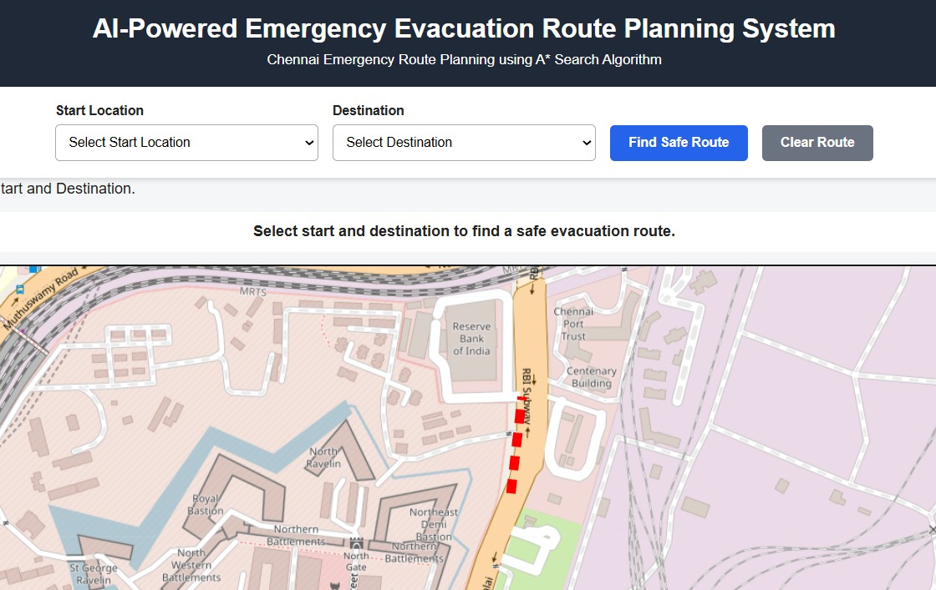
Fig D.1 Blocked road
D.2 Flooded road highlighted in orange.
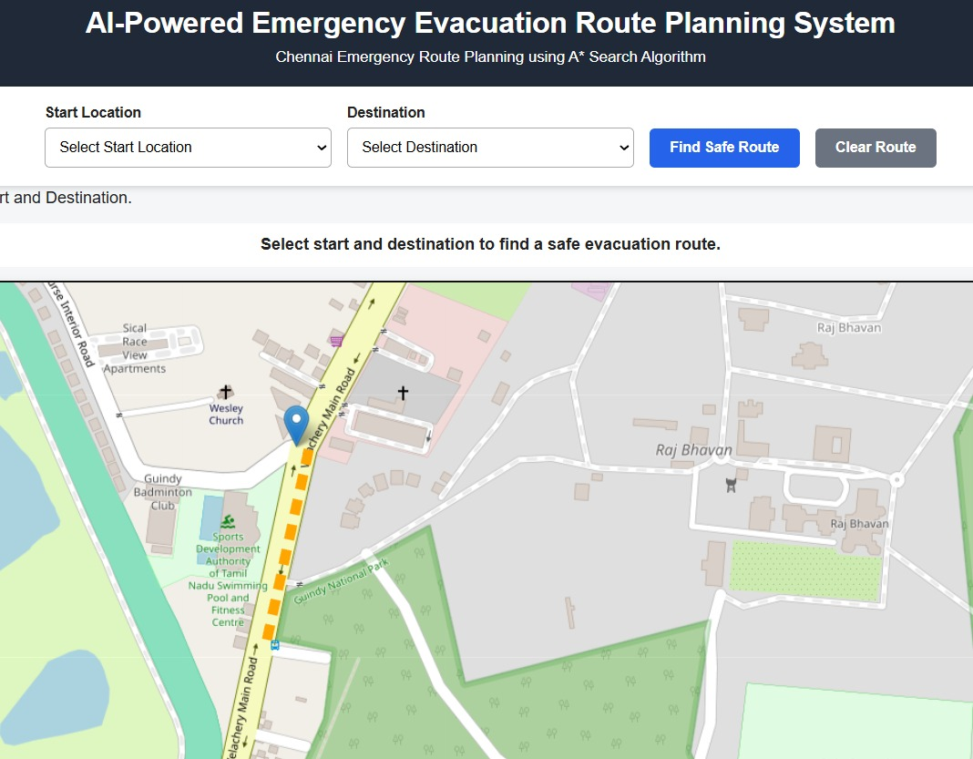
Fig D.2 Flooded road
D.3 Safe route displayed after a hazard is applied.
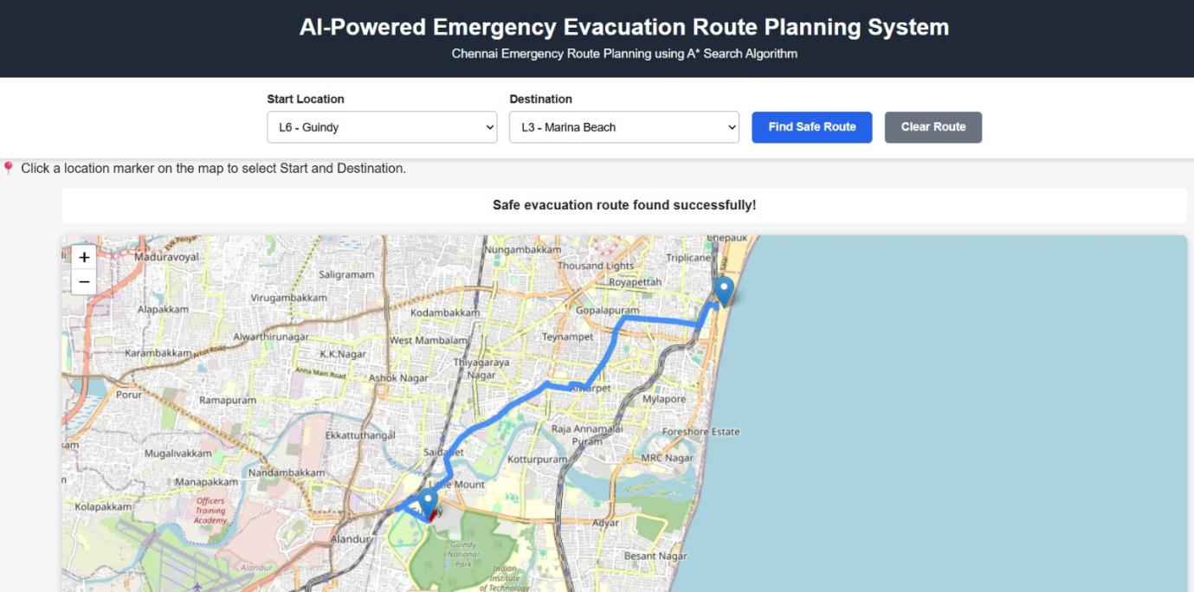
Fig D.3 Safe Route

